HURST GREEN PRIMARY SCHOOL


Positive Conduct Policy

Policy for the attention of
Audience | Key Audience | Optional Audience | Additional/Notes
Senior Leadership Team | √
Teachers | √
Teaching Assistants | √
Administrative Staff | √
Lunchtime Supervisors | √
Site Manager |  | √
Cleaners |  | √
Governors | √
Parents | √
Website | √
Local Authority |  | √

Review frequency | Annually
Previous versions agreed | New policy replacing Behaviour & Discipline  10 February 2025
This version agreed | 2 December 2025
Next review date | Autumn 2026

Statement of behaviour principles

1 Introduction

At Hurst Green Primary School, we foster a culture of high expectations, respect, and positive behavior. We believe every pupil can succeed and expect positive, respectful interactions, good manners, and strong relationships. Our goal is for pupils to have an enjoyable, challenging, and rewarding school experience in a secure environment where they feel safe, confident, and able to learn. We encourage all pupils to commit to their learning and always strive for excellence.
Pupils should demonstrate a commitment to their learning and strive to be the best that they can be, at all times. We should never accept or provide second best.
- Pupils have the right to learn without distraction and the responsibility to allow others to do the same.
- Pupils have the right to grow and flourish as individuals and the responsibility to allow others to do the same.
- Pupils have the right to be respected and have the responsibility to treat others the same.
- Pupils have the right to be safe and the responsibility to keep others safe in school.
- Good attendance and punctuality to school must be valued by all and common place.
- Positive behaviour that promotes our school values is explicitly taught, modelled, encouraged, and rewarded.

We owe it to every single child to have the highest expectations of conduct, regardless of the challenges some may have to meet them.

2 Aims
This document sets out the framework of Hurst Green Primary School’s approach to encouraging good behaviour known as ‘Positive Conduct.’
The framework should be successful in:
- Providing much greater understanding of the conduct process for pupils, parents/carers, teachers, and governors.
- Ensuring that all pupils, regardless of ability, age and gender are involved in the process of praise, recognition, and rewards.
- Reducing staff workload through the increased efficiency and effectiveness of the consequence system.
- Creating the best learning environment.

3 Positive Conduct in the Classroom and Around the School
To maintain a conducive learning environment, all staff will apply the school values and use the Code of Conduct system, ensuring a consistent approach when dealing with unacceptable conduct. Pupils know what is expected of them, the consequences of negative conduct and, where possible, how they can put it right (before or after any consequence has been applied). The expectations of pupils within school have been outlined already in this policy. In terms of establishing a key set of rules for the classroom and around the school, we recognise the importance of simplicity.

4 Responsibilities

The Headteacher will:
- Communicate, model the school’s values, and expected conduct.
- Work with the behaviour lead to review and approving this behaviour policy.
- Ensure that the school environment encourages positive behaviour.
- Ensuring that staff deal effectively with poor behaviour.
- Monitor how staff implement this policy to ensure rewards and sanctions are applied consistently to all groups of pupils.
- Ensure that all staff understand the behavioural expectations and the importance of maintaining them.
- Provide new staff with a clear induction into the school’s behavioural culture to ensure they understand its rules and routines, and how best to support all pupils to participate fully.
- Offer appropriate training in behaviour management, the impact of special educational needs and disabilities (SEND), and mental health needs on behaviour, to any staff who require it, so they can fulfil their duties set out in this policy.

The Governing Body will:
- (Under section 175 of the Education Act 2002) make arrangements to ensure that their functions are carried out with a view to safeguarding and promoting the welfare of children.
- Ensure that the school provides an environment that promotes positive behaviour in order for effective learning to take place. Governors will respect and both the school’s values and the Code of Conduct.

The Senior Leadership Team will:
- Support and empower any members of staff who are experiencing challenging behaviour, by helping them to improve their practice.
- Embody the school's core values, ensure the consistent and equitable application of the Code of Conduct, and establish high aspirations for the school community.

All staff will:
- Build positive, caring relationships with every pupil so that they feel valued, understood, safe and cared for.
- Model the school’s values and fairly apply the Code of Conduct whilst showing compassion to pupils.

Parents will:
- Collaborate with the school and support the systems and structures related to behaviour management and behaviour for learning.
  - When on school grounds, parents are expected to respect the behaviour principles, the school’s values, and Code of Conduct.

Pupils will:
- Take full responsibility for their own learning and actions throughout the day.
- Be aware of both the school values and the Code of Conduct and to accept that a consequence is a direct result of their conduct: this includes both positive and negative consequences.

5 School Values:

School values are fundamental beliefs that the school views as being of central importance and form the foundation on which our school operates. These are the values that we want our pupils to have fully aligned with their own personal values by the time they leave Year 6.
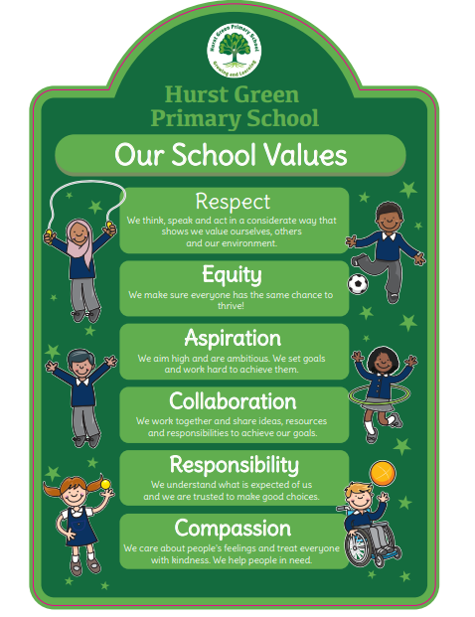

6 Philosophy

    - Not all behaviours are a matter of ‘choice’ and not all factors linked to the behaviour of children are within their control. Therefore, the language of choice (e.g. ‘good choice/bad choice’) is not always helpful.
    - Behaviour must always be viewed systemically and within the context of important relationships (i.e. a relational communication pattern rather than an internal problem).
    - Encouraging parental engagement and involvement is crucial when addressing and planning support for children’s SEMH needs.

7 Graduated Response
A graduated response to behaviour refers to a tiered approach used to manage and address children’s behaviour, where interventions or strategies are applied based on the severity or frequency of the behaviour. The idea is to match the response to the specific needs of the child, providing support at different levels depending on how the behaviour evolves.
Here is how it typically works:
- Low-level behaviour: The initial response focuses on proactive and preventative measures, like clear expectations, positive reinforcement, or gentle reminders. These are often used to prevent minor disruptions before they escalate.
- Moderate behaviour: If the behaviour continues or escalates, more targeted interventions are used, such as providing additional support, individualised strategies, or temporary consequences like a time out.
- High-level behaviour: For more serious or persistent issues, a more intensive intervention is required. This might involve one-on-one support, behaviour plans, or seeking help from external professionals.
The goal of a graduated response is to provide an escalating level of support and consequences, while also being mindful of the individual needs of each child. It ensures that interventions are fair, consistent, and appropriate for the situation.

8 Building Relationships

Labeling a child as "misbehaving" leads to punishment, while seeing them as "struggling" encourages support. The key to children feeling valued and secure is their connection with staff, who must show care and attention to their needs. Strong, fair, and consistent relationships are essential, with staff maintaining control while also being approachable and helpful. If staff face challenges with a child or group, they are expected to seek support for positive change. This policy guides staff in promoting positive behaviour, offering consistent procedures while allowing flexibility for individual needs, as detailed in the appendix.

Building positive relationships with parents is vital in being able to work together when supporting a child having difficulties or where an incident has occurred. For most children (unless there are specific safeguarding concerns), teachers should liaise directly with the parents if they have concerns about a child’s behaviour. This should be via our online behaviour system, face-to-face or phone call to ensure there is a conversation about the child/incident.

More serious or persistent behaviours are logged on our behaviour system which links into CPOMS. Depending on the child and any support work taking place – this contact may be done with support from or by members of SLT.

9 Promoting and Rewarding Positive Behaviour

We use a positive behaviour managment system that rewards positive behavior, encouraging children to remain "Green." This system sets clear expectations for behaviour, promoting safety, respect and learning.

Children can earn points for actions reflecting our school values, which accumulate to reach different thresholds and awards (see appendix 1). Staying "Green" is expected behaviour and not rewarded with points. Points may be awarded based on individual needs to ensure equitable recognition. Points can also be earned through teamwork, with table points encouraging collaboration.

9.1 Points
To ensure that points are ‘high status‘, teachers can award 1 point to children for demonstrating our school values, while the Senior Leadership Team (SLT) can award up to 2 points for exceptional contributions, ensuring equitable recognition.

The Points Pyramid
The points pyramid is a simple system that helps pupils understand how positive or negative consequences are given based on their behaviour choices. Points are awarded for demonstrating our school values, and any necessary negative consequences are guided by our Code of Conduct.
Rewards for Accumulated Individual Points:
- 50 points: Bronze Certificate
- 125 points: Silver Certificate and a star badge (badge colour is specific to each year group).
- 200 points: Gold Certificate and a small prize.
- 300 points: Platinum Certificate and a non-uniform day.
*(note: the thresholds have been adjusted pro rata for the remaining weeks in the 2024-25 academic year.)
Bonus Points:
- Pupils can earn bonus points for keeping it green for:
  - 10 weeks: 10 points
  - 20 weeks: 20 points
  - 30 weeks: 30 points
  - Every week: 50 points
Note: These weeks do not need to be consecutive.
- Special bonus points include:
  - Mention Assembly: 5 points
  - Special Mention Assembly: 10 points
  - Lunchtime Award: 5 points
  - Table of the Week: 2 points
  - Star writer: 2 points

House Points
House points are awarded by staff and pupils with leadership responsibilities. Points are exchanged with the class teacher. Staff and pupils must only issue one token at a time to ensure fairness and consistency.
If house points are awarded by anyone other than the class teacher (e.g. middays, pupil leaders, SLT etc.) a token will be issued which will be exchanged with the class teacher for a point on TrackIt Lights.

House Collaboration:
Points earned by pupils contribute to their individual total as well as their house total. At the end of each term, the house with the most points will enjoy a non-uniform day as a reward for their teamwork and effort.

9.2 Positive behaviour is also encouraged through:

- Praise and positive language - this is the first stage of reward and celebration.
- Specific language and gesture - This could be a ‘thumbs up’ or by describing a positive action explicitly e.g. ‘Well done, you have completed all of your work’.
- Points - These are referred to throughout the day. They are visible to children on the IWB using the TrackIT Lights system.
- Messages home to parents -are used to share positive behaviour and rewards. Parents are encouraged to engage with the associated Parent App.
- Celebration ‘Mention’ assemblies - Each week assemblies are used to celebrate children who have exhibited our values or positive behaviours associated with our values. Every term, parents are invited in to see children awarded for ‘Special Mentions’ assemblies.
- Special responsibilities/privileges.

9.3 Promoting Good Conduct Through the School Curriculum

The curriculum has a vital role to play in developing pupils’ positive behaviour and attitudes to learning. This includes teaching about fundamental British values: mutual respect for all and an understanding of the importance of democracy; the rule of law; individual liberty and tolerance for those with different faiths and beliefs and for those without faith. As part of the My Happy Mind program, pupils will be equipped with strategies to effectively manage challenging their own emotions and difficult situations.

Pupils are explicitly taught what constitutes good behaviour choices and what the consequences of good behaviour are.

Social, emotional and behaviour skills are taught within the curriculum so that this, together with our effective wider work, supports pupils to be confident, resilient, and independent, and to develop strength of character.

Teaching styles and approaches to managing behaviour reflect our commitment to restorative practice and building relationships.

10 Restorative Practice

Our role is to teach the pupils we have now—not those we wish we had or used to have.

The Restorative Approach focuses on resolving conflicts peacefully and fairly by ensuring all voices are heard and respected.

We uphold a Code of Conduct rooted in respect, responsibility, compassion, collaboration, equity, and aspiration. Any time these values are not respected, restorative practices help pupils understand the impact of their actions and resolve conflicts.

By fostering informed decision-making, restorative approaches teach pupils how their behaviour affects others and instills our core values.

When conflict arises, adults ensure everyone is heard and resolution is fair. Pupils are encouraged to recognise the impact of their actions, propose solutions, and prevent recurrence.

Through Attachment Awareness and Emotion Coaching, we promote self-regulation and create an environment conducive to learning.

10.1 Scripted responses
We aim to have a universal language around behaviour, therefore we use scripted responses. These are specifically designed to facilitate quick and clear communication regarding behaviour expectations and to provide immediate feedback. This approach serves to:
- Reinforce Positive Behaviour: Acknowledge and praise pupils who demonstrate expected behaviours, thereby encouraging repetition of these positive actions.
- Address Behaviour Issues: Provide straightforward and effective responses to behaviour that does not meet school expectations, ensuring that pupils understand the consequences of their actions.
By implementing these scripted responses, we aim to create a predictable and supportive environment that promotes respect, responsibility, and a culture of high standards throughout our school community. When staff use scripted responses, they will refer to our school values and the Code of Conduct.

Responses to Promote Positive Conduct | Responses to Challenge Negative Conduct
"I like how you are showing our school value of respect by listening to your classmates!"  "I really like how you are showing our school value of responsibility by keeping your area tidy!"  "I love how you are showing our school value of collaboration by helping your friend with their work!" | "You're not meeting our expectations right now. Remember, we need to be respectful to everyone."  "I noticed you're breaking our Code of Conduct by not following directions. Let's try to listen better."  "You're not showing our school values right now, and that’s not okay. We need to keep our classroom a safe place for everyone."
If the child responds…
“You have made a wonderful choice. This is the person who I need to see today. Thank you”

10.2 About Restorative Language
Our Restorative Approach resolves conflicts by ensuring fairness and respect for all voices. We also use scripted language for our restorative conversations (see table below). Restorative questions are designed to promote reflection, understanding, and accountability among pupils. These questions encourage pupils to consider their actions and the impact those actions have on others, thereby fostering a sense of responsibility and empathy within our school community.

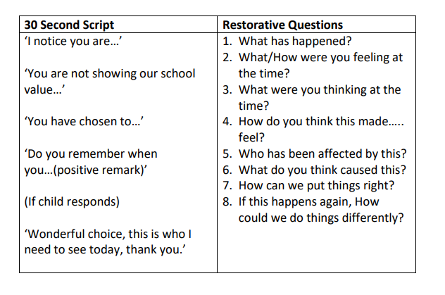

11 Unwanted/Unacceptable Conduct

At Hurst Green Primary School, we have a Code of Conduct for which pupils must adhere to. If a pupil breaks the Code of Conduct of Conduct, they will be given the appropriate consequence. See Appendix 1.

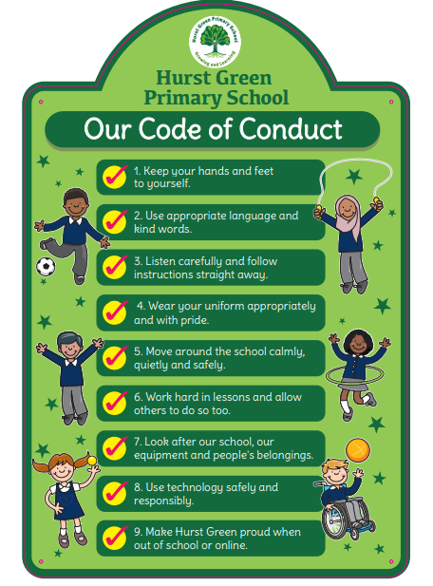

11.1 Behaviour Consequence Pyramid
Where appropriate, teaching and learning staff are expected to use behaviour and class management strategies before issuing warnings. The consequence system operates as follows:
- First Warning (Orange)
If a pupil breaks the Code of Conduct, a first (orange) warning will be recorded on the Trackit Lights system. At this stage, staff will remind the pupil of the school’s behaviour expectations and the Code of Conduct.
- Second Warning (Yellow)
If the inappropriate behaviour continues, a second (yellow) warning will be issued. The class teacher will have a reflective conversation with the pupil at the end of the lesson, which will take place during the pupil’s playtime.
Staff are required to regularly monitor pupils who are receiving frequent yellow warnings. If a pupil receives three or more yellow warnings over a two-week period, parents will be contacted to inform them of the ongoing concerns.
- Escalation to Red
If a pupil receives three warnings in one day (a further warning after they are already on Yellow), this will result in a red consequence.
- Red Consequence
A red consequence is issued either if:
- a pupil receives three warnings in one day
- displays a higher-level behaviour (refer to Appendix 3).
A consequence for being issued a Red may include:
  - Missing playtime and lunchtime
  - Parent are to be informed
  - Pupil to be put on a behaviour support plan
Here are examples of ‘Higher-Level’ behaviours that will result in an immediate red consequence:
- Fighting or physical aggression
- Using verbal abuse or discriminatory language
- Engaging in dangerous actions or damaging property
- Refusing to follow instructions from staff
These behaviours are serious and will be addressed to maintain a safe and respectful school environment.
All red consequences will be recorded on the Trackit system, and parents will be notified through the parent app.
- Three Red Consequences in a Week
If a pupil receives three red consequences in one week, a formal meeting will be held with a member of the leadership team. Additional consequences may include the pupil working in a leadership-designated space for a period of time deemed appropriate for their age and the behaviour displayed. Additionally, further intervention may be required from internal and external agents.
- Further Consequences
In cases of serious or persistent behaviour issues, further consequences may include:
  - Internal exclusion
  - Suspension
  - Permanent exclusion
This system is designed to ensure a consistent and supportive approach to behaviour management, promoting a safe and respectful learning environment for all pupils.

11.2 Behaviour Incidents Outside of School
Consequences may apply for poor conduct off-site when a pupil is:
- Participating in school-organized activities (e.g., trips)
- Traveling to or from school
- Wearing school uniform
- Otherwise identifiable as a pupil of the school
Sanctions may also apply for off-site behaviour at any time if it:
- Disrupts the orderly running of the school.
- Threatens another pupil.
- Harms the school’s reputation.

11.3 Online Misconduct

The school can issue behaviour sanctions to pupils for online misconduct when:
- It poses a threat or causes harm to another pupil.
- It could have repercussions for the orderly running of the school.
- It adversely affects the reputation of the school.
- The pupil is identifiable as a member of the school.

11.4 Suspected Criminal Behaviour
If a pupil is suspected of criminal behaviour, the school will make an initial assessment of whether to report the incident to the police. When establishing the facts, the school will endeavour to preserve any relevant evidence to hand over to the police. If a decision is made to report the matter to the police, the headteacher or member of the Senior Leadership Team will make the report. The school will not interfere with any police action taken.
However, the school may continue to follow its own investigation procedure and enforce consequences, as long as it does not conflict with police action.
If a report to the police is made, the Designated Safeguarding Lead (DSL) will make a tandem report to Children’s Social Care, if appropriate.

11.5 Child-on-child abuse

The school ensures all child-on-child abuse incidents are addressed appropriately and never ignored. Pupils are encouraged to report any concerns, no matter how small.

Responses will be proportionate, considered, supportive, and case-specific. Clear procedures include:

- Responding to reports
- Conducting risk assessments to decide whether to:
- Manage internally.
- Refer to early help.
- Contact social care.
- Report to police.

11.6 Consequences for Poor Conduct

“Too often we forget that discipline really means to teach, not to punish. A disciple is a student, not a recipient of behavioural consequences.”
(The Whole Brain Child - Siegel. D., 2011)

Hurst Green Primary School responds to unacceptable behavior with fair, consistent, flexible, and proportionate consequences.

Staff explain the reason for consequences, relate them to the Code of Conduct, highlight needed changes, and emphasise that consequences address actions, not individuals.

The Senior Leadership Team empowers staff to manage most behaviour at the class level.

Possible consequences include:

- Recording behavior in the Track It Lights management system.
- Reminders or Code of Conduct and potential consequences of continued misconduct.
- Reflective/restorative conversations.
- Time out or sending the pupil to a partner class.
- Missing break or lunchtime.
- Communication with parents.
- Referral to senior staff.
- Agreeing a behaviour contract
- Having a home/school behaviour chart/book
- Setting of written tasks such as an account of their behaviour
- Expecting work to be completed at home, or at break or lunchtime.
- School-based community service, such as tidying a classroom.
- Internal exclusion.

Personal circumstances of the pupil will be considered when choosing sanctions and decisions will be made on a case-by-case basis, but with regard to the impact on perceived fairness.

For serious cases, the Headteacher may suspend or permanently exclude a pupil, following a thorough investigation as per the Exclusions Policy. Suspensions and exclusions are reported and monitored by the Governing Body and the Local Authority.

Behaviour incidents are logged on Trackit Lights, which in turn records ‘Red’ incidents on CPOMS. These are regularly reviewed by staff and leadership to ensure appropriate follow-up actions.

11.7 Pupils with SEND

The school recognises that pupils’ behaviour may be impacted by a special educational need or disability (SEND) and, therefore, some pupils may require a more sensitive and differentiated approach to meet the behaviour expectations. When incidents of poor conduct arise, we will consider them in relation to a pupil’s SEND, although we recognise that not every incident of misconduct will be connected to their SEND. Decisions on whether a pupil’s SEND had an impact on an incident of misconduct will be made on a case-by-case basis.

When dealing with misconduct from pupils with SEND, especially where their SEND affects their behaviour, the school will balance their legal duties when making decisions about enforcing the behaviour policy.
The legal duties include:
- Taking reasonable steps to avoid causing any substantial disadvantage to a disabled pupil caused by the school’s policies or practices (Equality Act 2010)
- Using our best endeavours to meet the needs of pupils with SEND (Children and Families Act 2014)
- If a pupil has an Education Health Care Plan (EHCP), the provisions set out in that plan must be secured and the school must co-operate with the local authority and other bodies.

As part of meeting these duties, the school will anticipate, as far as possible, all likely triggers of misconduct, and put in place support to prevent these from occurring. Any preventative measures will consider the specific circumstances and requirements of the pupil concerned.

Our approach to anticipating and removing triggers of misconduct below are detailed below:
      - Adjusting seating plans to allow a pupil with visual or hearing impairment to sit in sight of the teacher.
      - Training for staff in understanding conditions such as autism.
      - Use of separation spaces (sensory zones or nurture rooms) where pupils can regulate their emotions during a moment of sensory overload.

The school’s Special Educational Needs and Disabilities Coordinator (SENDCo) may evaluate a pupil who exhibits challenging behaviour to determine whether they have any underlying needs that are not currently being met.

Where necessary, support and advice will also be sought from specialist teachers, an Educational Psychologist, medical practitioners and/or others, to identify or support specific needs.

Where acute needs are identified, we will liaise with external agencies and plan support programmes for that child. We will work with parents to create the plan and review it on a regular basis. The school is aware that the provisions set out in an EHCP must be secured (if applicable).

11.7.1 Support Structures

The SENDCo, Behaviour Lead, and Headteacher will assess pupils exhibiting challenging behaviour to adapt the behavior approach to help them meet behaviour standards. This may involve creating a Positive Coping Plan (PCP), an individual risk assessment, or tailored parental reporting system. These systems are based on prioritising the positives for the child and knowing they can succeed. These documents are used to support pupils back to their regulated state and to identify the signs of dysregulations.

When needed, the school will seek support and advice from specialists, including Educational Psychologists, medical professionals, or other experts, to identify and address specific needs. For pupils with acute needs, we will collaborate with external agencies and work closely with parents to develop and regularly review tailored support programs.

12 Suspensions and Exclusions

The Headteacher will decide whether to suspend or exclude a pupil, considering all the circumstances, the evidence available, and the need to balance the interests of the pupil against those of the whole school community. In the case of a Permanent Exclusion, the GB Discipline Committee will meet within 15 days to decide whether to uphold the Headteacher’s decision or re-instate the child back to school.

The Headteacher may consider the following questions:

- Is the behaviour in breach of the school Positive Conduct Policy? If so, have any other consequences described in the policy been used and to what effect? Could any other consequences be used as an alternative with the parents’ agreement?

- Has the school previously supported the child (what/when/what level of impact did this have?) Does the child have any recognised behaviour problems? Have reasonable adjustments already been made or could they now be made? (Evidence could be SEN documentation e.g. EHCP, PCP, Risk Assessments). Even if the child does have a recognised behaviour problem the school has a duty of care to all children. If the risk to others cannot be controlled, then suspension/exclusion should be considered.

- Would allowing the child to remain in school seriously harm the education or welfare of other children or adults?

Once all other considerations have been made, then a suspension/exclusion may be applied. In this case, the school will follow Local Authority guidelines and DfE suspension/exclusion procedures.

If the Headteacher is unavailable and/or uncontactable, then the Deputy Headteacher, can issue a suspension in the Headteacher’s absence, provided attempts to contact the Headteacher have been made.

It is illegal for the school to send home a pupil due to poor behaviour unless via a suspension or exclusions.

The pupil will be provided with work for the first five days of a suspension. Parents will receive a letter outlining the reason for the suspension and the length of time. A meeting will be held with the child and parents when the child returns to school. The school will adhere to Local Authority, DFE and relevant legal guidelines for suspensions.
https://www.gov.uk/government/publications/school-exclusion

The Local Authority may be contacted by the school for advice on individual and general matters relating to exclusion.

13 Uniform
Hurst Green Primary School’s uniform policy is designed to encourage a purposeful and effective climate for learning. All pupils and staff should be smart and take pride in their appearance, be dressed appropriately within the ethos of a school/working environment. All pupils should be aware that they represent the school, its ethos, and its image, when wearing the school uniform inside or outside of school.
It is expected that all pupils wear full uniform at all times, unless directed otherwise by staff.

14 Searching, Screening and Confiscation

14.1 Confiscation of inappropriate items:

Schools’ general power to discipline enables us to confiscate, retain or dispose of a pupil’s property as a disciplinary penalty, where reasonable to do so. The law protects the school from liability in any proceedings brought against us for any loss of, or damage to, any item they have confiscated, provided we acted lawfully.

Any prohibited items (listed in section 14.3) found in a pupil’s possession will be confiscated. These items will not be returned to the pupil. We will also confiscate any item which is harmful or detrimental to school discipline. These items will be returned to pupils after discussion with senior leaders and parents, if appropriate.

We will follow the DfE Guidance on confiscation carefully when deciding how to manage or dispose of confiscated items. Searching and screening pupils is conducted in line with the DfE’s latest guidance on searching, screening and confiscation.

14.2 Mobile Phones and Smart Watches

Y6 pupils may bring mobile phones to school but must hand them in at that start of each morning and collect them at home time. Staff will remind pupils to follow this rule if phones are seen during the day.

Other electronic devices such as e-books and smart watches, are not permitted unless approved by the Headteacher. If found, they will be confiscated and returned to parents/carers at the end of the day. Repeated violations or refusal to hand over a device will result in consequences and SLT intervention.

Staff are protected by law from liability for damage or loss of confiscated items when acting lawfully.

14.3 Searches

Staff have the power to search without consent for prohibited items including:

- Knives and weapons
- Alcohol
- Illegal drugs
- Stolen items
- Tobacco and cigarette papers
- Fireworks
- Pornographic images
- Any article that has been or is likely to be used to commit an offence, cause personal injury or damage to property; and
- Any item banned by the school rules which has been identified in the rules as an item which may be searched for.

We will:
- Ensure that staff authorised by the Headteacher carry out searches for prohibited items only.
- Ensure that any searching of a pupil will be implemented consistently, proportionately, and fairly, in line with the school’s policy.
- Seek cooperation from the child for the search. Where this is not given, sanctions in line with this Positive Conduct Policy will be applied.
- Where cooperation is still not given, staff will assess, on a case-by-case basis, whether reasonable force should be applied (the member of staff should consider whether
- conducting the search will prevent the pupil harming themselves or others, damaging property or from causing disorder)
- By law, have a same sex member of staff conducting the search, and another member of staff present as a witness.
- Report searches to parents and on our central behaviour log.
- Regularly report incidents of searches to governors

14.4 Strip Searches
- Under no circumstances will staff ever attempt to conduct a strip search: only Police can lawfully do this.
- Before calling Police in to school, we will consider whether introducing the potential for a strip search through police involvement is absolutely necessary, and will always ensure that other appropriate, less invasive approaches have been exhausted.
- We will follow statutory guidance rigorously.
- While the decision to undertake the strip search itself and its conduct are police matters, school staff retain a duty of care to the pupil(s) involved and will advocate for pupil wellbeing at all times.
- Where reasonably possible, parents will be informed before the search.

15 Physical Intervention/Reasonable Force
Reasonable force covers a range of interventions that involve physical contact with pupils. All members of staff have a duty to use reasonable force, in the following circumstances, to prevent a pupil from:
- Causing disorder.
- Hurting themselves or others.
- Damaging property
- Committing an offence.
Incidents of reasonable force must:
- Always be used as a last resort.
- Be applied using the minimum amount of force and for the minimum amount of time possible.
- Be used in a way that maintains the safety and dignity of all concerned.
- Never be used as a form of punishment.
- Be recorded and reported to parents and discussed with the headteacher.
- When considering using reasonable force, staff should, in considering the risks, carefully recognise any specific vulnerabilities of the pupil, including SEND, mental health needs or medical conditions.
See Appendix 4 for link to Use of Reasonable Force – advice for Headteachers, Staff and Governing Bodies.

16 Discriminatory Language and Abuse

The school has a zero-tolerance approach to discriminatory language and abuse. Any use of language or actions that target an individual or group based on characteristics such as race, gender, disability, religion, sexual orientation, or any other protected characteristic will be treated as a serious breach of our Code of Conduct. All incidents will be addressed promptly and proportionately, with appropriate consequences and restorative measures.

All incidents of discriminatory language or abuse will be referred to the Headteacher. These will be recorded on Track-It and CPOMs and parents of the victim and perpetrator will be spoken to. Incidents will be reported to the Governors.

The school is committed to educating pupils on the impact of discrimination and fostering a culture of respect, inclusion, and equality, and we do this explicitly and implicitly through our curriculum and all our interactions.

Support will be provided to those affected, and repeated or severe incidents may involve external agencies and lead to further disciplinary action, including, where appropriate, suspension or exclusion.

17 Zero-Tolerance approach to Sexual Harassment and Sexual Violence

The school will ensure that all incidents of sexual harassment and/or violence are met with a suitable response, and never ignored.

Pupils are encouraged to report anything that makes them uncomfortable, no matter how ‘small’ they feel it might be.

The school’s response will be:

Proportionate

Considered

Supportive

Decided on a case-by-case basis.

The school has procedures in place to respond to any allegations or concerns regarding a child’s safety or wellbeing. These include clear processes for:

Responding to a report.

Carrying out risk assessments, where appropriate, to help determine whether to:

Manage the incident internally.

Refer to Early Help

Refer to children’s social care.

Report to the police.

Please refer to our Child Protection and Safeguarding Policy for more information.

18 Bullying
Bullying is defined as the repetitive, intentional harming of one person or group by another person or group, where the relationship involves an imbalance of power.
Bullying is, therefore:
- Deliberately hurtful
- Repeated, often over a period of time.
- Difficult to defend against

Bullying can include:

Type of bullying | Definition
Emotional | Being unfriendly, excluding, tormenting
Physical | Hitting, kicking, pushing, taking another’s belongings, any use of violence
Discriminatory | Racial taunts, graffiti, gestures, homophobic, or sexist comments etc.
Sexual | Explicit sexual remarks, display of sexual material, sexual gestures, unwanted physical attention, comments about sexual reputation or performance, or inappropriate touching
Direct or indirect verbal | Name-calling, sarcasm, spreading rumours, teasing
Cyber-bullying | Bullying that takes place online, such as through social networking sites, messaging apps or gaming sites

Details of our school’s approach to preventing and addressing bullying are set out in the Hurst Green Primary School Anti-Bullying Policy.

19 Lunchtime Supervision

At lunchtime, supervision is by the team of mid-day supervisory assistants and at least one member of the Senior Leadership Team (who will supervise any children missing lunchtime). The team should maintain order; usually by reminding children of the standard of behaviour expected. Lunchtime staff will follow the school Positive Conduct Policy. To help promote our school values, lunchtime supervisors will be able to reward pupils using tokens.

The children should treat the supervisory staff with the respect due to all adults at Hurst Green Primary School. Breaches of the Code of Conduct, and verbal or physical aggression/abuse is not tolerated. Serious misconduct or repeated disobedience at lunchtime is brought to the attention of the Headteacher/Deputy Headteacher. This results in loss of privileges and break times. Parents will be informed if there is no improvement in behaviour and the child may be internally excluded at lunchtime for a set period. This could be followed, if necessary, by a Suspension or Permanent Exclusion.

20 Training, Monitoring and Evaluating

20.1 Training
As part of their induction process, our staff are provided with regular training on managing behaviour, including training on:
- The expectations of the school including the Positive Conduct Policy
- The needs of the pupils at the school
- How SEND and mental health needs impact behaviour
Behaviour management will also form part of continuing professional development. Staff keep their individual training log up to date on Blue Sky.

20.2 Monitoring and evaluating school behaviour

The school will collect data on the following:
- Behavioural incidents, including removal from the classroom.
- Attendance, permanent exclusion, and suspension
- Use of pupil support units, off-site directions, and managed moves
- Incidents of searching, screening, and confiscation
- Anonymous surveys for staff, pupils, governors, and other stakeholders on their perceptions and experiences of the school behaviour culture.

The data will be analysed every term by the SLT and governors.

20.3 Monitoring this policy
This behaviour policy will be reviewed by the headteacher and the full governing body annually, or more frequently, if needed, to address findings from the regular monitoring of the behaviour data (as per section 20.2) or to adapt to new local or national legislation. At each review, the policy will be approved by the governing body.

20.4 Data Protection
This policy adheres to the principles under data protection law. For further information please review the school’s data protection policy published on the school’s website.

Appendix 1
Points Pyramid

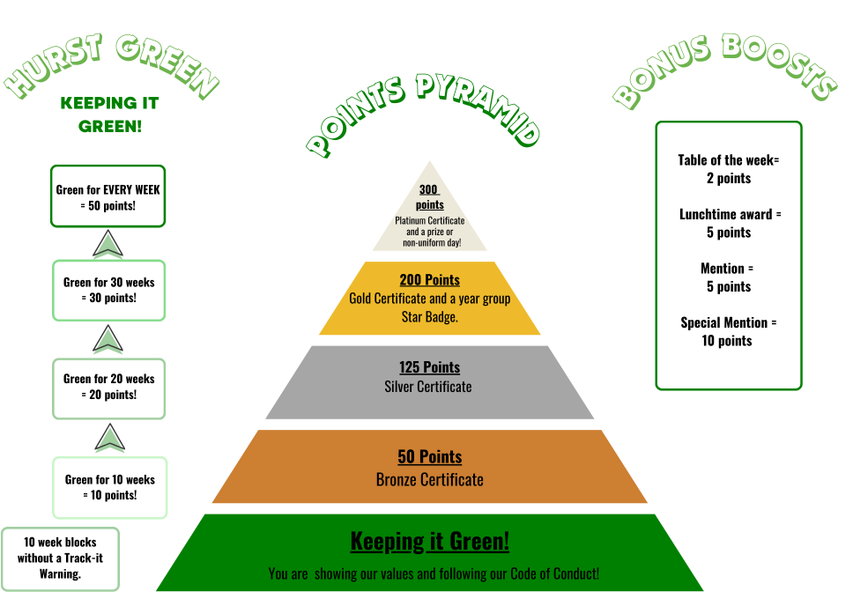

Appendix 2
Consequence Pyramid

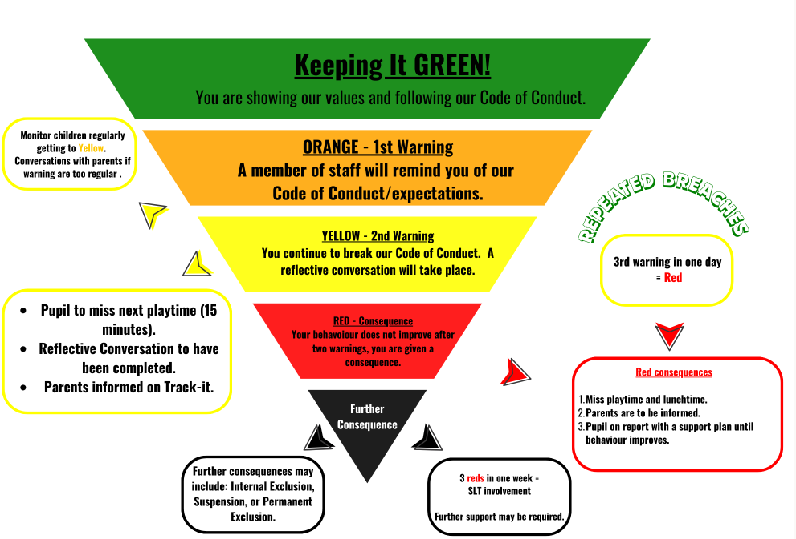

Appendix 3- Behaviour Categories

